Evaluation for task

Task 3 was a bit more complicated in the code needed to put it together. Its purpose is to develop upon task 2 and be able to read the two files created, and using those, create the original sentence including all its punctuation, capitalisation etc. For mine I made a menu where you can navigate to different functions such as compressing a file and decompressing a file.

My task 3 does exactly what it’s supposed to in the smoothest way I could make it. It has a navigational menu which directs the user in the correct direction as to what they want to do. It’s built in three parts using functions. Compressing, Decompressing and the Menu.

I don’t think difficulty is the right word to use here, but task really wasn’t that hard. Since most of the code in the functions is from task 1 and 2. The only part you had to come up with Is the decompression of the files which is just the opposite of compressing, and the menu design to navigate around the functions. Honestly, it was just time consuming because for each little update I did to task 1 or 2, I had to change that piece of code in task 3 which was annoying, but, it worked.

Let’s take a look at the criteria list from the task analysis for task 3.

* Reading files
* Case sensitive list reading
* Case sensitive list creating
* Taking lists and making sentences from files
* Various inputs
* Functions to execute code when required

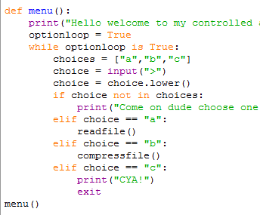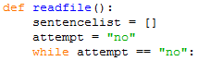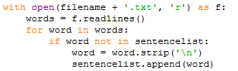

Using inputs to take user to desired function

Using functions so code can be used to later on.

Reading files and creating case sensitive lists from the words in the file.